A Metrological Fuel Surveillance Application Based on Internet of Intelligent Vehicles
Alternate Title: Smart System for Fuel Supervision
Objective:
Main goal is to supervise the fuel consumption of vehicles and to get the location of nearest fuel station.
Abstract:
Fuel supervision systems are designed to monitor fuel consumption within your vehicle. They accurately measure and track fuel inventories. This information is then displayed in systems and reported to the user.
With a fuel supervision system, you benefit from improved fuel efficiency, which helps to prevent fuel waste. When you track vehicle maintenance and driver routes, you can utilize this system to make cost-effective decisions, such as implementing more efficient driving routes and encouraging better driver behavior, both of which will improve fuel efficiency.
With the help of our supervision system, the fuel storage tank level is monitored on site once the fuel is transferred from the delivery tank. This information is automatically updated on the monitoring system and provides data on the current fuel level in the tank.
Here our proposed system has arduino UNO, liquid flow sensor, liquid level sensor, LORA and 16X2 LCD. The liquid flow sensor is connected to inlet of fuel tank detects the amount of fuel filled in storage tank and displays it in 16X2 LCD. Then the liquid level sensor is fixed inside the fuel tank below reserve so whenever the fuel is low it alerts and displays in 16X2 LCD. Now the user get to know the fuel level now he press the button and sends the transmission signal through LORA to get the location of nearest fuel station.
Existing System:
The existing system metrological fuel surveillance application based on internet of intelligent vehicles consists of an OBD-II| (on board diagnostics) and android application to get the output.
Proposed system:
Proposed system monitor the fuel level through on board display with help of fuel level sensor and get the nearest fuel station location using LORA whenever fuel level drops below threshold.
Block Diagram:
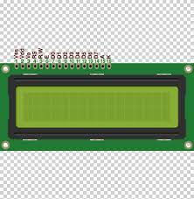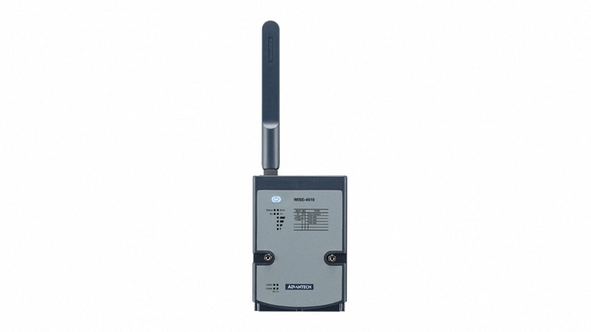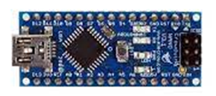
Water level sensor
Water flow sensor
Arduino NANO

Arduino NANO
LORA
LORA
16X2 LCD

Hardware Requirements:
- Arduino NANO-2
- LORA-2
- Liquid Flow Sensor
- Liquid level Sensor
- 16X2 LCD
Software Requirements:
- Arduino IDE

